MINISTRY OF EDUCATION AND SCIENCE OF

THE KYRGYZ REPUBLIC

ALA-TOO INTERNATIONAL UNIVERSITY

ENGINEERING AND INFORMATICS FACULTY

COMPUTER SCIENCE DEPARTMENT

THESIS TITLE GOES HERE

DIPLOMA THESIS

By Name Surname
Thesis Supervisor: Assoc. Prof. Dr. Isa Muslu

Bishkek – May 31, 2023

MINISTRY OF EDUCATION AND SCIENCE OF

THE KYRGYZ REPUBLIC

ALA-TOO INTERNATIONAL UNIVERSITY

ENGINEERING AND INFORMATICS FACULTY

COMPUTER SCIENCE DEPARTMENT

TITLE OF THE THESIS HERE


DIPLOMA THESIS
By Name Surname

Thesis Supervisor:  Assoc. Prof. Dr. Isa Muslu | Date:  May 31, 2023
Head of Department:  Dr. Ruslan Isaev | Date:  May 31, 2023

Bishkek – May 31, 2023

ALA-TOO INTERNATIONAL UNIVERSITY

ENGINEERING AND INFORMATICS FACULTY

COMPUTER SCIENCE DEPARTMENT

ABSTRACT

THESIS TITLE HERE

By Name Surname

DIPLOMA THESIS
The purpose of this project is to develop an application called "Mathematical terminology dictionary in four languages", which is supported by Android smart-phones. The goal of improving and creating a new mathematical dictionary is no embarrassment in understanding mathematical terminology with the active use of local students and students from different countries. The uniqueness of this diploma work is that the first and the only mathematical dictionary will appear in Kyrgyzstan in four languages (Kyrgyz, Russian, English, Turkish) in android operating system. The construction of this dictionary was on Android Studio, which is one of the most important programs for Android and other platforms. The dictionary contains more than 2563 terms.
Key words: Dictionary, Mob.App, Smartphones, Mathematical terminology, Android Studio

Thesis Supervisor: Assoc. Prof. Dr. Isa Muslu Date: May 31, 2023

АЛА-ТОО ЭЛ АРАЛЫК УНИВЕРСИТЕТИ

ИНЖЕНЕРДИК ЖАНА ИНФОРМАТИКА ФАКУЛЬТЕТИ

ИНФОРМАТИКА ЖАНА ЭСЕПТӨӨ ТЕХНИКАСЫ КАФЕДРАСЫ

АННОТАЦИЯ

ДИПЛОМДУК ИШТИН АТЫ

Аткарган Аты Жону

ДИПЛОМДУК ИШ
Бул проекттин максаты Андроид смартфондорунда иштеген «4 тилде математикалык терминология сөздүгүн түзүү жана ишке ашыруу» программасын иштеп чыгуу болуп саналат. Жергиликтүү жана ошондой эле чет өлкөлүк студенттер арасында математикалык терминдерди түшүнүүдө жана колдонууда кыйынчылык жаралат, андыктан жаңы математикалык сөздүктүн иштеп жана өнүктүрүп чыгуунун максаты алардын ишин жеңилдетүү. Кыргызстанда алгачкы жолу төрт тилде (кыргызча, орусча, англисче, туркчө) математикалык сөздүктүн пайда болушу бул дипломдук иштин өзгөчөлүгү болуп эсептелет. Бул сөздүк Андроид жана башка платформалар үчүн өтө маанилүү болгон Андроид Студионун негизинде түзүлгөн. Сөздүк 2563 төн көп терминдерди ичине камтыйт.
Ачкыч Сɵздɵр: Сөздук, Смартфон, Математикалык терминология, Андроид Студио

Илимий Жетекчиси: И.и.к., доц Иса Муслу Датасы: Май 31, 2023

МЕЖДУНАРОДНЫЙ УНИВЕРСИТЕТ АЛАТОО

ФАКУЛЬТЕТ ИНЖЕНЕРИИ И ИНФОРМАТИКИ

КАФЕДРА ИНФОРМАТИКИ И ВЫЧИСЛИТЕЛЬНОЙ ТЕХНИКИ

АННОТАЦИЯ

НАЗВАНИЕ ДИССЕРТАЦИИ
Выполнил Имя Фамилия

ДИПЛОМНАЯ РАБОТА
Цель этого проекта заключается в разработке приложения под названием «Разработка и реализация словаря математических терминологии на четырех языках», которое поддерживается Андроид смартфонами. Цель улучшения и создания нового математического словаря, это, не затруднение в понимании математических терминологии при активном использовании местных студентов и студентов из разных стран. Уникальностью данной дипломной работы является то, что в Кыргызстане появится первый и единственный математический словарь на четырех языках (кыргызский, русский, английский, турецкий). Строительство данного словаря было на Android Studio, который является одним из очень важных программ для Андроид и других платформ. Словарь содержит более 2563 терминов.

Ключевые Слова: Словарь, Моб.Приложения, Сматрфон, Математические терминологии, Андроид Студио

Научный Руководитель: К.и.н., доц Иса Муслу Дата: Май 31, 2023

TABLE OF CONTENTS
ABSTRACT 2
АННОТАЦИЯ 3
АННОТАЦИЯ 4
TABLE OF CONTENTS 5
LIST OF FIGURES 7
LIST OF TABLES 8
LIST OF ABBREVIATIONS 9
ACKNOWLEDGEMENTS 10
INTRODUCTION to Basics 1
CHAPTER 1 2
1 BACKGROUND AND LITERATURE REVIEW 2
1.1 Research Objectives and Approach(Heading 2) 3
1.2 Scope of the Application(Heading 2) 3
1.3 Features of the Project 3
1.3.1 Subtitle 2 (Heading 3) 3
1.4 Goal of the project 4
1.4.1 Equations 4
1.4.2 Figures 4
1.4.3 Tables 6
2 TECHNICAL AND ANALYTICAL EVALUATION 7
2.1 Amvm Knv 8
CHAPTER 3 9
3 SYSTEM ARCHITECTURE AND DESIGN 9
3.1 Subtitle 1 9
CHAPTER 4 10
4 RESULTS 10
4.1 Subtitle 1 10
4.2 Subtitle 1 10
4.2.1 Subtitle 2 10
CONCLUSION 11
REFERENCES 11

LIST OF FIGURES
Figure 1.1: DNdw Annwdnf 6
Figure 1.2: Example photo with high resolution. Caption created with “insert, reference, caption, figure” and the style changed to “thesis-figure caption.” 6

LIST OF TABLES
Table 1-1: Steps in creating a table 7
Table 2-1: Styles used in this template 8

LIST OF ABBREVIATIONS

ACKNOWLEDGEMENTS
Its customary and good manners to say thank you however, where do you draw the line? In some of the theses that I have read, and I write this after having read thousands, literally, the following and more have been acknowledged: God, one’s advisor, one’s better half, parents, children, friends, classmates etc.
Keep in mind that one has to use one’s own words when writing an acknowledgement.

June 4, 2020
Bektur Atabekov

INTRODUCTION
The main purpose of your introduction is to identify a problem that is worthy of investigation. It must also provide some idea of your research goals and approach to research. Specific objectives can be introduced in the introduction chapter or they can be saved for later after you have provided additional background on the topic and state of the current research and its gaps. The Introductory chapter often concludes with a summary of the organization of the thesis, including identification of the general content of specific chapters and appendices.
Ideally, introduction defines the overall importance of the problem areas and provides an introduction into what you did, chapter two is why you did it in the context of what was previously known, three is how you did it, four is what you found and five is what it all means – putting the pieces together, (what’s your contribution to the research field).
It should be noted that the objectives of your research define the OUTCOME, i.e. what will be learned. They are not a statement of the approach or tasks that are required to meet these objectives. Some examples of reasonable research objectives:
- Determine the effect of Marangoni convection on mixing of molten glasses
- Predict the extent of mechanical degradation of polymers
These both define the resulting outcome (prediction, effect on…) so they are objectives. The related tasks or research approach could be:
- Solve a set of coupled non-linear PDEs…
- Perform experiments on…
These define the required steps; they do not define the outcome so they are NOT objectives.
Some theses and dissertations can have some chapters written as manuscripts that can be submitted to peer-reviewed scientific research journals. In that scenario, the graduate student should be the principal author of the pending articles. The thesis or dissertation that includes manuscripts as chapters are not exempt from writing an introduction, background/ literature review and overall conclusions and recommendations.
This template uses the MS WORD STYLES extensively to help keep your work in the proper format. These paragraphs use the “thesis-body text” style that is set for Times New Roman, 12 point font with double spaced lines and extra spacing between paragraphs (no need for hard carriage returns). There are also styles for headers, equations, captions and bulleted lists that you can choose to use. See examples throughout this template.

CHAPTER 1

BACKGROUND AND LITERATURE REVIEW
The background and literature review section needs to provide sufficient fundamental background information about the subject to support your objectives, hypothesis (or research questions) and methods, and review the pertinent literature related to the specific problem / hypothesis you are addressing. In Johnson (1991), some of the questions that he listed that the literature review should be to answer include:
- what are the fundamental science, math, engineering concepts related to your research (scope),
- what part of your research work has ever been investigated before and what has not, (some of this may have been included in the introduction)
- how does your research work relate to that done by others,
- how have others defined/measured/identified the key concepts of your research,
- what data sources have you used or have other researchers used in developing general explanations for observed variations in a behavior or phenomenon in a concept in your thesis etc.
The lit review (~20 pages or more) should not be limited to the above questions only. Ingeniousness and creativity is expected of a grad student.
Bullets can be single-spaced. The above bullets are in the style “thesis-bullets.” When you type bulleted text, highlight the bulleted text and then select “thesis-bullets” from under the format, style menu to automatically change their formatting as above.

Research Objectives and Approach(Heading 2)

Scope of the Application(Heading 2)
Given the length of each chapter, it is required to use titles and subtitles (possibly sub-sub titles). These can be numbered or one can just rely on different formats. The section titles in this document are labeled “heading 2” (“heading 1” was used for chapter titles). The heading styles formats should be consistent throughout the document as it helps significantly in creating the automatic table of contents.

Features of the Project

Subtitle 2 (Heading 3)
The subtitles here have a different format (“heading 3”) than the section titles.

Goal of the project
You can even get to another level of headers, defined here as “heading 4.” The table of contents, however, is currently set up to just include three levels of headers.

Equations
Equations can be created in MS WORD equation editor or they can be created with other software. Equations should be numbered. They can be numbered within each chapter (e.g., 2.1, 2.2) or they can be numbered sequentially throughout the entire thesis. Equations should be indented or centered with the equation number to the right. The example below and associated “thesis-eqn” style can be used for all your equations.
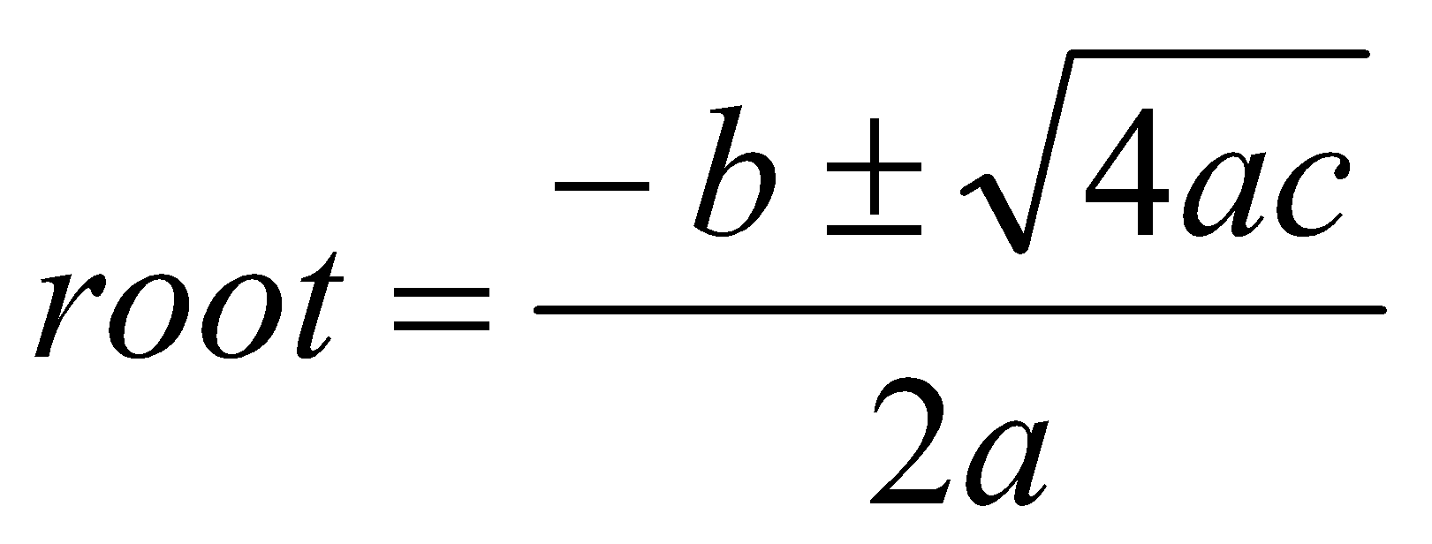 [1]
This equation was written with the equation editor. Found through “insert, object, and equation editor 3.0. The equation editor can also be found through “tools, customize, commands”, and in categories, look for insert and in the commands section, look for equation editor, drag and drop the icon onto the toolbar. This editor is fine for relatively simple equations, other options are available for more complex equations.

Figures
Figures and illustrations are a necessary means of communicating technical information. Often times, figures included in the background/lit review section are copied from existing copyrighted information. In all cases, this is technically inappropriate without also receiving permission from the copyright owner. Citing the source of the figure is not sufficient. This rule is enforced for PhD dissertations because they are submitted to ProQuest for electronic access by others. The enforcement of this rule for MS theses is dependent on the specific committee members.
Resolution of figures is often a problem in theses. Resolution should be >300 dpi, preferably 600dpi (Error! Reference source not found.). You should note that saving images as jpeg files is a sure way to lower the resolution to an unacceptable extent. From experience, a good way is to copy your graphic (for example from PowerPoint or excel) and when pasting it into word, use the “paste special” “as an “enhanced metafile” (Error! Reference source not found.). This also substantially reduces the resulting file size in comparison with pasting graphs in as excel graphics.
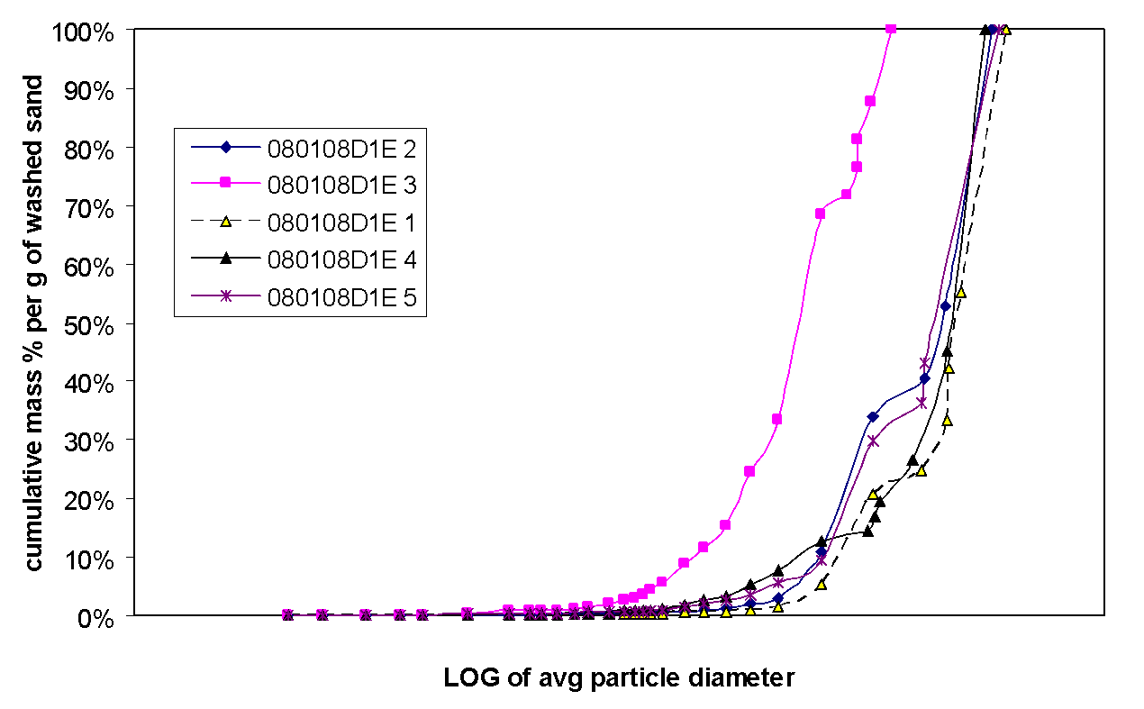
Figure 1.1: DNdw Annwdnf

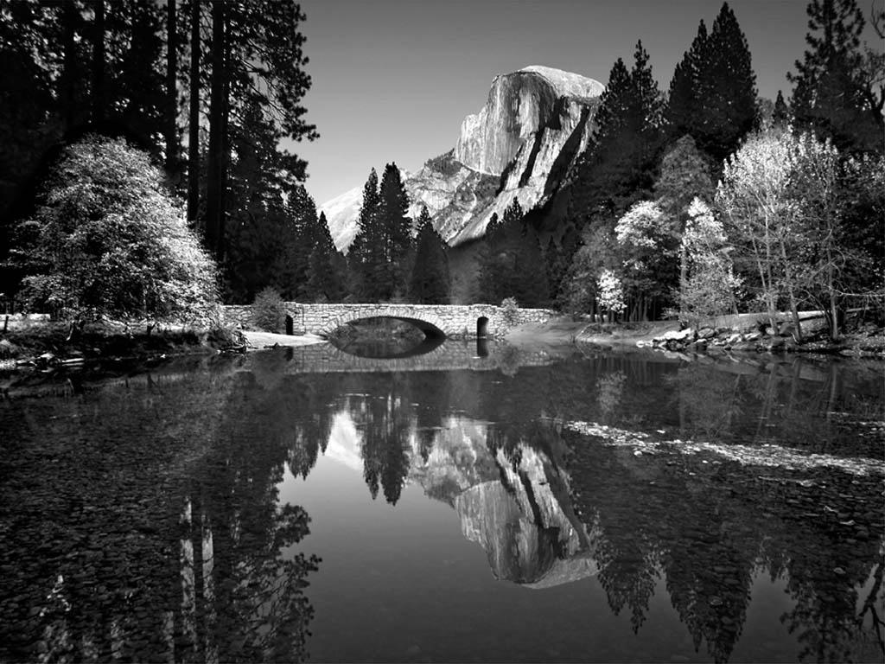
Figure 1.2: Example photo with high resolution. Caption created with “insert, reference, caption, figure” and the style changed to “thesis-figure caption.”

Tables
Tables should have meaningful information with descriptive headers. You can use the “thesis-table caption” style to define your captions and refer to the table in the text with a “cross reference” (Error! Reference source not found.). MS Word re-numbers table captions automatically when new tables inserted. Nevertheless, you need to right click on any cross references and “update field” if there are changes.
Table 1-1: Steps in creating a table
Step # | Instruction
Create table caption | Insert, reference, caption, table
Format the caption | Format, style, “thesis-table-caption”
Create table | Table, insert…
Format the table | The formatting of the table can vary, including use of single space as appropriate. Most journals require that tables are formatted using table style “Table Simple 1” format.
Reference the table from the text | With the cursor at the location you want to cite the table: insert, reference, cross reference, table, label and number only.

CHAPTER 2

TECHNICAL AND ANALYTICAL EVALUATION
In addition to the detailed methods you need to describe in this section, you need to provide specific objectives and an overview of your approach if they have not already been presented in the introductory chapters. The best place to put those items can vary among theses. Sometimes the background and lit review is really necessary to justify and substantiate the specific objectives and approach and, therefore, it is best to save those details for the beginning of this chapter.
These paragraphs are in “thesis-body text.” Other styles including captions, headers etc. can be used as presented in the previous chapter. Error! Reference source not found. summarizes all of the styles that can be used with this template.

Table 2-1: Styles used in this template
Style name | When used
Heading 1 | Chapter titles
Heading 2 | Primary headers
Heading 3 | Sub headers
Heading4 | Sub-sub headers
Thesis-body text | All paragraphs
Thesis-bullets | Bullets
Thesis Figure caption | All figure captions.
Thesis table caption | All table captions
Thesis-eqn | equations
Thesis-reference | Reference list at end of thesis

Amvm Knv

CHAPTER 3

SYSTEM ARCHITECTURE AND DESIGN
Results, findings, discussion of results OR manuscripts. It is best to also reiterate information in your literature review to help substantiate the findings of your research.
This template is best used for directly typing in your content.

Subtitle 1

CHAPTER 4

RESULTS

Subtitle 1

Subtitle 1

Subtitle 2

CONCLUSION
This chapter could also be called “Conclusions and Recommendations” or “Conclusions and Implications.” In general, there should be no new information presented here. It should be a synthesis of information that you have already discussed.

REFERENCES
Includes all references: articles, media facts, books, reports, regulations, internet articles, papers that you referenced from the text. In the text, citations can be (Smith and Jones, 2007) or Smith et al., 2007) (if more than two authors) if you wish to present your references alphabetically. Alternatively, you can include the citations in the text as a number [1] or ¹ if you wish to present your references numerically. The computer software “End Notes” (Alatoo doesn’t have a site license) or the MS WORD tools – “insert, reference, footnote, endnote” (or “cross reference” if you refer to the same reference more than once) should be used to help you organize and manage your references.
References can be written in single space with extra space between references as in the format below. There are many different ways to arrange the information and punctuation in a reference listing. The most important thing is to make sure all references are complete and that the format of your references is consistent throughout.
Example, S.Z. (2008). How to cite a complete journal reference. J. Complete Thesis. 1(2): 47-52.
Example, S.Z., Second, W.S. (2007). How to cite a complete conference proceedings paper. In: Proceedings, 2nd International meeting of Masters Students, Paper # XW15 (Potsdam NY, November, 2007).

Appendix A
Type or paste your appendices here. Appendices are a place to organize and include all of the “extra” material that is important to your research work but that is too detailed for the main text. Examples can include specific analytical methods, computer code, spreadsheets of data, details of statistical analyses, etc. Nevertheless, these materials do not speak for themselves. There should be a reference to these materials from the main chapters (complete details included in Appendix A) and there should be some text at the beginning of each appendix to briefly explain what the information is and means that is included in that appendix.

